

Epicor 10

EPR Model

MSD

Authors:

Matus HUdak,

Document generated: 26th Sep 2017

Epicor-Logo-BI-2color-White-Transparent-BKNGD-CMYK.emfEpicor-Logo-BI-2color-White-Transparent-BKNGD-CMYK.emf

The contents of this document are for informational purposes only and are subject to change without notice. Epicor Software Corporation makes no guarantee, representations or warranties with regard to the enclosed information and specifically disclaims, to the full extent of the law, any applicable implied warranties, such as fitness for a particular purpose, merchantability, satisfactory quality or reasonable skill and care. This document and its contents, including the viewpoints, dates and functional content expressed herein are believed to be accurate as of its date of publication, June 2017. The usage of any Epicor software shall be pursuant to the applicable end user license agreement and the performance of any consulting services by Epicor personnel shall be pursuant to applicable standard services terms and conditions. Usage of the solution(s) described in this document with other Epicor software or third party products may require the purchase of licenses for such other products. Epicor, the Epicor logo, are trademarks of Epicor Software Corporation, registered in the United States and other countries. All other marks are owned by their respective owners. Copyright © 2017 Epicor Software Corporation. All rights reserved.

Table of Contents

MSD E10 process model 3

Demand Management 5

DM001 Forecast Entry 6

Customer Relationship Management 7

CM001 Customer CRM Calls 8

CM002 Customer CRM Cases 9

Procurement 10

PUR001 Requisitions 11

PUR002 Requisitions Approval 12

PUR003 Purchase Order Suggestions 13

PUR004 Purchase Orders 14

PUR005 Purchase Order Approval 15

PUR006 Container Definition 17

PUR007 Request for Supplier Quotes 18

Receiving Goods and Products 19

REC001 Receipts 20

Inventory/Warehouse 22

INV001 Pallet Carton Packaging 23

INV002 inventory Movements 24

INV003 Inventory Counts 25

INV004 Stock Inspection 26

Inspection 27

INS001 Inspection Process 28

Sales Management 29

SAM001 Case Creation 30

SAM002 Sales Orders 31

SAM003 RMA 33

Shipping 34

SHP001 Case Order fulfillment 35

SHP002 Truck Allocation 37

SHP003 Customer Shipments 39

SHP004 Transfer Orders 41

Integrations 43

# MSD E10 process model

|  |  |
| --- | --- |
|  | Version:  Version 1.0  Date:26th Sept 2017 |
|  |  |
|  |  |

The objective of this document is to have an overview of Epicor business processes with consideration towards MSD processes, the Epicor ERP modules to be implemented and any gaps highlighted on high level that may arise.

This section details the aims and objectives of the document. This document is not intended to be an in depth review of the business but to identify the business logic understanding of what the business is, who/how/where/when etc.

This review is the result of 5 day of interview with the staff of MSD and as such, is the consultant’s interpretation of the facts as heard. It does not intend to present every process in detail, only to determine whether the writer has a basic understanding of the Company.

This document is considered a ‘living’ document throughout the project implementation and will be updated as and when necessary. For example, if the initial agreed version suggest a one phase project implementation and has been written and approved on that basis and subsequently the project is to be split into two or more phases, then this document should be updated and re-issued for review and approval.

The following item(s) are included as they have been touched upon during the workshop:

Customer Relationship Management

Demand Management

Purchasing

Quality Assurance

Supplier Relationship Management

Inventory Management

Sales Management

Reporting Requirements related to the above modules

* Epicor 10 Standard Reports currently available
* Report requirements associated with SSRS/ Crystal reports configurations during implementation.

Abbreviations used:

BPM – Business Process Management configuration (technical configuration using available tools)

Enhancement – Customization to provide additional functionality not available in system

Configuration – setup of specific data, or usage of existing functionality to achieve result

Custom fields – addition of User Defined fields to an existing object

Integration – integrating third party software with Epicor 10 application.

Dashboard – a custom screen that allows to view existing data in a specific way as well as make calculations with this data.

|  |  |
| --- | --- |
|  |  |

Quantification The process of quantification includes two critical steps: demand management and supply management. Both of these steps should be accomplished in E10 Demand Management

The following item(s) are in this Group:

* DM001 Forecast Entry

|  |  |
| --- | --- |
|  | User Notes |
|  | Process Group definition:  This group contains the process related to definition and creation of Forecast records in Epicor 10 database which are used to generate demand requirements for MSD on a short and long term basis (up to 1 year). The topic included here are:   * Creation of Forecast records * Keeping forecast records |
|  |  |

DM001 Forecast Entry

|  |  |
| --- | --- |
|  | User Notes |
|  | Process definition:  This process starts with the identification of demand, which done outside of the system by a planning process where MSD are looking at forecasts extending up to 1 year into the future.  This workflow starts from the forecast record, which can hold demand quantity for a specific date and for a particular item defined in the database. A user will create such forecast records, by either importing them to Epicor 10, or creating them manually as and when needed in each plant. |

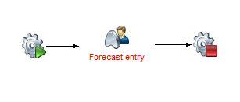

15. Process: SC001 Forecast Entry

Process Content

* Entry of the forecast Record into E10

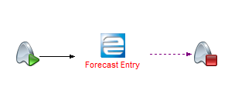

16. Process: DM001 Forecasts and Forecast Entry

Once forecast data being entered into system, the E10 should be able to provide future situation by using different automation options; interpolation and apply trend analysis linked with the MSD financial information over the next 12 months.

**GAPs/ Configuration changes Identified:**

|  |  |  |  |
| --- | --- | --- | --- |
| Definition | Type |  | Comments |
| Forecast Dashboard | Dashboard |  | A dashboard to provide more clarity relating to forecasts |
| Time-phase dashboard | Dashboard |  | Allow to display time phase related information for multiple items |
| Trend analysis | Dash board |  | Allow to show future trend. Bases forecast on existing historical trend data |

Next gap: Record of past imported forecasts are not kept in the system

See attached narration of forecast 

Supply Management

The following item(s) are in this Group:

* SM001 Forecast Entry

|  |  |
| --- | --- |
|  | User Notes |
|  | Process Group definition:  This group contains the process related to definition and development of supply plan in Epicor 10 database which are used to generate procurement quantities for MSD on a short and long term basis (up to 1 year). The topic included here are:   * Suggestion of delivery quantities * Suggestion of delivery date |

SM001 Supply planning

|  |  |
| --- | --- |
|  | User Notes |
|  | Process definition:  This process starts by defining maximum level, minimum level, buffer stock level and lead-time level within each plant. The defined levels will facilitate MSD at looking forward at creating delivery schedules.  This workflow starts from the forecast record, stock on hand, pending shipments and adjustments (expiries) which definitely can produce delivery dates and delivery quantities extending up to 1 year into the future for a particular item defined in the database. Such delivery schedules will be automation created in E10 through obtianed data records mentioned above.  Once suggestion being generated, the E10 should allow staff with access to change the suggestions manually. When planning shipments in E10, the E10 should provide two options: can use automatic shipment planning feature, or can do shipment planning manually. The difference between these two is that in automatic planning, E10 calculates the shipment quantity for you, in manual planning, staff will be able to change the suggested quantities and deliveries schedules if s/he wish. Each has its advantage or disadvantage depending on your situation. A supply plan is a living document, meant to be updated regularly |

**GAPs/ Configuration changes Identified:**

|  |  |  |  |
| --- | --- | --- | --- |
| **Definition** | **Type** |  | **Comments** |
| Month of stock (MoS) | Dashboard |  | It will show MSD capability to meet its customer demands. This calculation will be embedded on by disregarding stock on hand at companywide with more than 3 months to expire over the calculated average monthly forecast |
| The inventory plan | Dashboard |  | The Inventory Plan dashboard will shows estimation of inventory level for each item during each month, over the next 12 months |
| Delivery performance | dashboard |  | This will show levels of delivery schedule adherence in terms of percentage against the scheduled deliveries. |
| Call off dashboard | Dashboard |  | It should shows call Off Plan Forecasted against corresponding budget availability |

**Material Requirement Planning (MRP)**

With the current MRP, zonal customer orders /zonal transfer orders are inputs towards suggestions for new replenishment from suppliers. This sometimes misleads, therefore with the E10 system, zonal transfer orders or zonal customer orders should not be regarded as primary basis for new replenishment suggestions, only stock on hand at company level, planned deliveries should be the main primary basis for new replenishment suggestions.

However, we are recommending that MRP in E9 should work similar as MRP in E10 of which it will continue supporting zones to suggest their transfer order quantities.

See Attached narration for Supply Planning 

Customer Relationship Management

The following item(s) are in this Group:

* CM001 Customer CRM Calls
* CM002 Customer CRM Cases

|  |  |
| --- | --- |
|  | User Notes |
|  | Process Group definition:  This group contains the processes that are used in CRM to support MSD processes in dealing with the customers by providing traceability by making use of calls and cases, which are records linking multiple objects together. |

CM001 Customer CRM Calls

|  |  |
| --- | --- |
|  | User Notes |
|  | Process definition:  This process can start at any point in time when customer communication needs to be recorded A customer call is opened with possibilities to link up this call against multiple records to track the nature of the call in Epicor. |

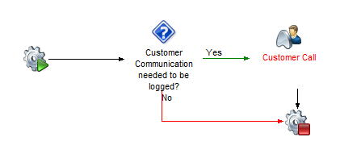

22. Process: CM001 Customer CRM calls

Process Content

* Customer Call received

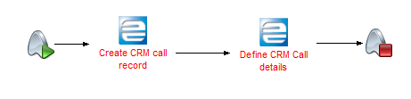

23. Process: CM001 Customer CRM Calls, Stage: Customer Call received

**GAPs/ Configuration changes Identified:**

|  |  |  |  |
| --- | --- | --- | --- |
| Definition | Type |  | Comments |
| N/A | N/A |  | N/A |

CM002 Customer CRM Cases

|  |  |
| --- | --- |
|  | User Notes |
|  | Process definition:  This process similar to CRM Call, can start at any point in time when customer communication needs to be recorded, but a case record is more specific to a investigation and traceability compared to CRM Call.  The link will start either side, any of the two parties i.e. Customer or customer service officer can initiate the flow of communication. The customer should be able to log in, order or upload order, send it to customer service or sales officer. The officer will accept it and start processes. The customer can at any time query about the order to understand it’s status or expected time of arrival, and if the query goes unresponded, supervisors and directors can view this. Once order has been fulfilled, the customer can provide feedback on the overall service or the officer in charge can communicate in case of any changes in the order or delays that may happen.  This application should be accessible on mobile phones to make sure that the customer can at any time see changes or report any queries about the order. Moreover, this will also allow the officer to send in notifications when the order has arrived, in the case of back orders when the items have arrived. Notification also on financial statements such as when the customer is in debt or has not purchased for a while.  In addition, this platform will serve as a key customer relationship management tool for building and retaining relationship with our customers by offering feedback on time and in depth of statuses of their orders. This will shorten the time lapse taken for letters to reach them, which eventually leads to dissatisfaction.  Moreover, in the spirit of service and building sustainable positive relationship with our customers, our end of the system will allow managers and directors to view the less contacted customers and raise it with the designated officers.  It is high time MSD had an interface that will actually connect with the customer on shorter time lapse and allow early feedbacks and responses to different queries they may have in medical supplies and equipments. |

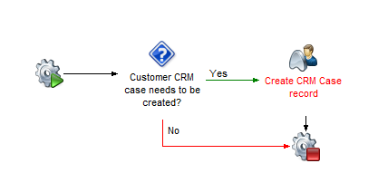

26. Process: CM002 Customer CRM Case

Process Content

* Create CRM Case Record

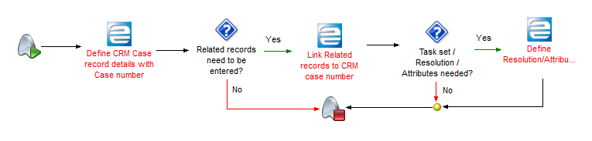

26. Process: CM002 Customer CRM Case, Stage Create CRM Case Record

**GAPs/ Configuration changes Identified:**

|  |  |  |  |
| --- | --- | --- | --- |
| Definition | Type |  | Comments |
| N/A | N/A |  | N/A |

Case management to consider both internal users ( employees) and external customers.

Procurement

The following item(s) are in this Group:

* PUR001 Requisitions
* PUR002 Requisitions Approval
* PUR003 Purchase Order Suggestions
* PUR004 Purchase Orders
* PUR005 Purchase Order Approval
* PUR006 Container Definition
* PUR007 Request for Supplier Quotes (RFQs)

|  |  |
| --- | --- |
|  | User Notes |
|  | Process Group definition:  This group contains the processes that are used in the business activities of a company all relating or impacting procurement. These include the following:         The creation of requisition to trigger internal demand  The approval of these requisitions based on requirement  Generating or creating manually purchase orders with proper details.  Approval of purchase order records per MSD requirement.  Creating Container records upon communication with the suppliers to flag containers in Database.  Creating Quotes against suppliers in order to procure items that are not yet being purchased regularly. |

PUR001 Requisitions

|  |  |
| --- | --- |
|  | User Notes |
|  | Process definition:  Requisition process starts by a user in a department creating a requisition to express internal demand for products, goods or services which is submitted to an approval before it can be processed further into purchasing. |

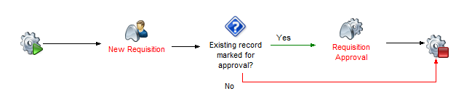

30. Process: PUR001 Requisitions

Process Content

* New Requisition:

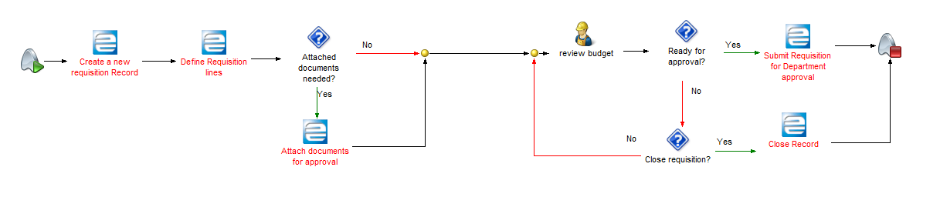

31. Process: PUR001 Requisitions, Stage: New Requisition

**GAPs/ Configuration changes Identified:**

|  |  |  |  |
| --- | --- | --- | --- |
| Definition | Type |  | Comments |
| Activity codes on requisitions | Enhancement |  | Activity codes to be viewable on requisition line with budget associated |
|  |  |  |  |
| Budget on requisition lines | Enhancement |  | Budget to be viewable on Requisition lines |
| There should be a mechanism to control Zonal procurement threshold during requisition generation. Where requisition total amount is above set threshold dispatching should be denied until threshold is approved by the respective Zonal manager | Enhancement of existing customization |  | To control zonal procurement threshold |

PUR002 Requisitions Approval

|  |  |
| --- | --- |
|  | User Notes |
|  | Process definition:  This process starts once a requisition record has been created and is flagged for approval. There are multiple steps that are needed by MSD to approve a requisition: Specification (attachments) need to be approved by quality department. Head of department where the requisition was created approves next. Available Budget is approved by finance at this point before it is moved to purchasing process in the form of Purchase suggestions. |

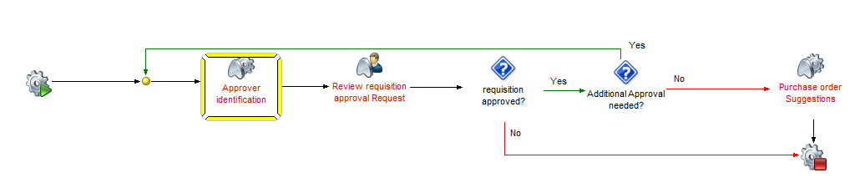

30. Process: PUR002 Requisitions Approval

Process Content

* Review Requisition Approval Request:

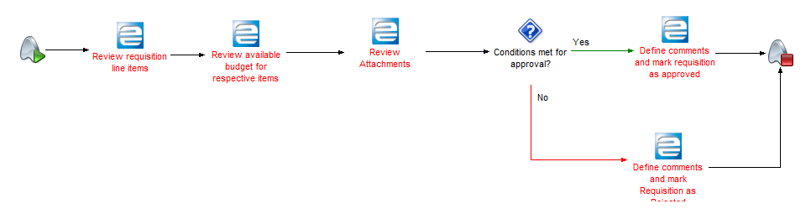

30. Process: PUR002 Requisitions Approval, Stage Requisition Approval Request

**GAPs/ Configuration changes Identified:**

|  |  |  |  |
| --- | --- | --- | --- |
| Definition | Type |  | Comments |
| Requisition approval matrix | Enhancement |  | A role specific approval matrix on requisitions with supported dashboards. |
| Notification of approval | Enhancement |  | Upon approval/ rejection a notification should be sent to initiator and Previous approvers |
|  |  |  |  |
| Enable change log | enhancement |  | To track changes done |

PUR003 Purchase Order Suggestions

|  |  |
| --- | --- |
|  | User Notes |
|  | Process definition:  This process is triggered either by running MRP process which generates purchasing requirements based on available stock or are being triggered by approved requisitions. |

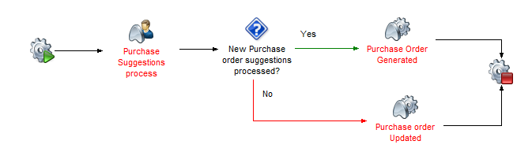

30. Process: PUR003 Purchase Order Suggestions

Process Content

* Purchase Suggestions Process

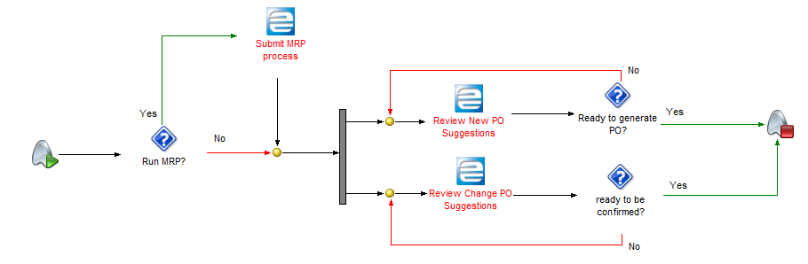

43. Process: PUR003 Purchase Order Suggestions, Stage: Purchase Suggestions process

**GAPs/ Configuration changes Identified:**

|  |  |  |  |
| --- | --- | --- | --- |
| Definition | Type |  | Comments |
| N/A | N/A |  | N/A |
| Po suggestion from MRP should be converted to requisition instead of PO | Enhance existing customization |  | Po suggestion from MRP should be converted to requisition and follows requisition approval process |

PUR004 Purchase Orders

|  |  |
| --- | --- |
|  | User Notes |
|  | Process definition:  This process can be started by a requisition, or can be done manually by defining a Purchase order directly or as a form of Purchase suggestion. MSD use 5 types of groups of products that can be procured: Normal Products, verticals ( third party items), Support services, Special procurement (Buy to order items), and MSD community items. A tendering process is also to be used (TANEPS) with a interface to Epicor 10 which results in generation of a Purchase order, which triggers additional transactions. Purchase contracts are expected to be used in Epicor 10, where Purchase orders will be linked to contract records. Items being purchased will be expected to hold donor and program information in the database for easy tracking and identification. |
|  | 30. Process: PUR004 Purchase Orders  Process Content   * Tender Process     30. Process: PUR004 Purchase Orders, Stage: Tender Process   * Purchasing Process     A  30. Process: PUR004 Purchase Orders, Stage: Purchasing Process  **GAPs/ Configuration changes Identified:**   |  |  |  |  | | --- | --- | --- | --- | | Definition | Type |  | Comments | | Permit requirement for particular items being purchased | Enhancement |  | Items that have special conditions require permits before they can be sold or purchased. | | Budget identification on Purchase order lines | Enhancement |  | Purchase orders are to obtain budgets on line level ( copied from requisitions if applicable). This should be mandatory | | Donor fields on Purchase order header/line | Custom Fields |  | Provide donor and program tracking on PO level. This should be mandatory. |   PUR005 Purchase Order Approval   |  |  | | --- | --- | |  | User Notes | |  | Process definition:  This process links up to Purchase orders, which are created in the system and allows MSD to properly review all aspects of the record before approving it, creating a control mechanism in place to allow purchases to happen in a controlled way, where changes made on the order will require reapproval. |     30. Process: PUR005 Purchase Order Approval  Process Content   * Review Purchase Order Approval Request |
|  | 30. Process: PUR005 Purchase Order Approval, Stage: Review Purchase Order Approval Request   * Approve Purchase Order     30. Process: PUR005 Purchase Order Approval, Stage: Approve Purchase Order   * Provide comments and reject Approval     30. Process: PUR005 Purchase Order Approval, Stage: Approve Purchase Order  **GAPs/ Configuration changes Identified:**   |  |  |  |  | | --- | --- | --- | --- | | Definition | Type |  | Comments | | A role based approval matrix for Purchase orders | Enhancement |  | A role specific approval matrix on Purchase orders with supported dashboards. | |
|  |  |
|  | PUR006 Container Definition   |  |  | | --- | --- | |  | User Notes | |  | Process definition:  Container records are used in the system to identify details related to containers at the time of dispatch, as well as additional documentation if received in advance. The containers can be tracked in the system until receipt is done with all related details. |     30. Process: PUR006 Container Definition  Process Content   * Container Creation/Dispatch |
|  | 30. Process: PUR006 Container Definition, Stage: Container Creation/Dispatch  **GAPs/ Configuration changes Identified:**   |  |  |  |  | | --- | --- | --- | --- | | Definition | Type |  | Comments | | N/A | N/A |  | N/A | | This functionality is customized in E9. Needs further investigation from your end as the processes | | | The terminologies used need to be revised to meaningful | |

PUR007 Request for Supplier Quotes

|  |  |
| --- | --- |
|  | User Notes |
|  | Process definition:  This process may be started in case MSD cannot supply a particular product and requires procurement from multiple suppliers. A RFQ record is created from which a quote towards multiple suppliers is done to obtain a price offer for specific quantity. This then allows to link up to the Purchase order processing in order to obtain required product. Once a user creates a Request for a Quote (RFQ) record, this can be linked across multiple suppliers to obtain their feedback regarding a quote. Upon receiving quotes back MSD can make an informed decision which supplier will be used for purchase. |
|  | 30. Process: PUR007 Request for Supplier Quotes  Process Content   * Create RFQ record      * Supplier response |
|  | **GAPs/ Configuration changes Identified:**   |  |  |  |  | | --- | --- | --- | --- | | Definition | Type |  | Comments | | N/A | N/A |  | N/A | |
|  |  |
|  |  |

|  |  |  |  |  |  |
| --- | --- | --- | --- | --- | --- |
|  | Receiving Goods and Products  The following item(s) are in this Group:   * REC001 Receipts  |  |  | | --- | --- | |  | User Notes | |  | Process Group definition:  Receipts process covers at MSD all forms of products, including services and is to be used in all forms of receipts. All receipts need to be supported by existing purchase order to ensure full traceability | |

REC001 Receipts

|  |  |
| --- | --- |
|  | User Notes |
|  | Process definition:  This process is started with the approval of a purchase order which is then used as a primary record against which a container can be placed, or a receipt made. Additional Charges or landed costs are expected to be utilized on Container receipts, and the need to integrate the Pallet and Carton/StockID integration at the time of receipt is required by MSD. |

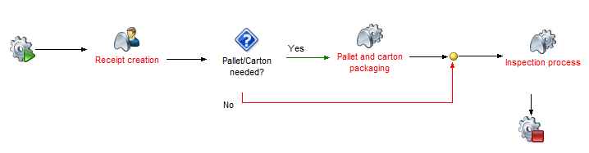

59. Process: REC001 Receipts

Process Content

* Receipt Creation

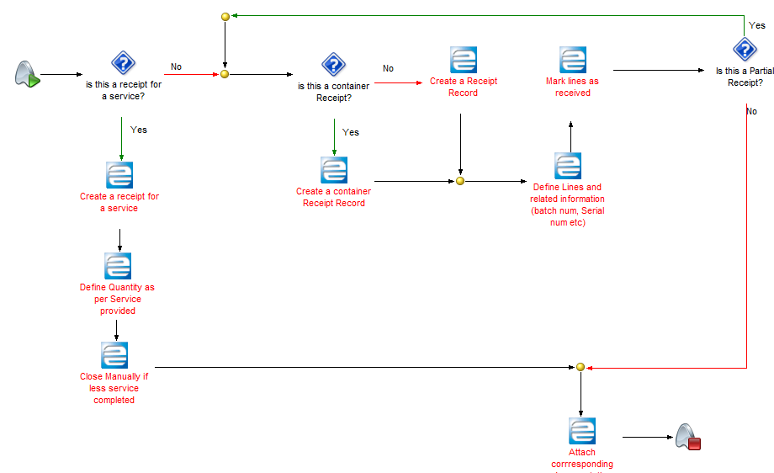

60. Process: REC001 Receipts, Stage: Receipt Creation

**GAPs/ Configuration changes Identified:**

|  |  |  |  |
| --- | --- | --- | --- |
| Definition | Type |  | Comments |
| Restrict receipts/container receipts if no PO | BPM |  | Disable the ability to receive a receipt without a PO |
| Restrict receipts if PO is not approved | BPM |  | Disable the ability to receive a receipt without an approved PO |
| Restrict creation of container shipment if PO is not approved. | BPM |  | Disable the ability to create container shipment without an approved PO |
| Barcode printout at the time of receipts or manually | Enhancement |  | Possibility to printout barcodes with proper details according to receipt |
| Report needed to define volume and weight of receipt | Dashboard/Report |  | Carton/stockID size and weight to be calculated and shown on report |
| Tracking of unused pallets | Dashboard/configuration |  | Pallets need to be tracked on stock in case they are not used. |
| Integration with package IDs to support Pallet and Carton | Configuration/Enhancement |  | The possibility to define a pallet and carton components at the time of completing a receipt |
| Amendment of already created Goods receipt note ( GRN) | Enhancement |  | Ability to amend GRN |
| Ability to create more than 10,000 carton IDs and Stock IDs per lot | Enhancement |  |  |
| Auto cleaning of empty pallets |  |  | Diassociate empty pallet ID with item code and lot |

Inventory/Warehouse

The following item(s) are in this Group:

* INV001 Pallet-Carton Packaging
* INV002 Inventory Movements
* INV003 Inventory Counts
* INV004 Stock Inspection

|  |  |
| --- | --- |
|  |  |
|  | |  | | --- | | User Notes | | Process Group definition:  This group contains the processes that are used in the business activities of a company.  These include the following:         The usage of packaging components of Pallets and cartons and assigning them to products, items as and when needed. Printing of Labels accordingly.  Inventory movements done inside MSD for movement and location of stock items.  Inventory counts done on a periodic basis or cycle counts utilizing ABC codes.  Inspection processes supporting requirements to count stock items and full traceability in further transactions (DMR) | |

INV001 Pallet Carton Packaging

|  |  |
| --- | --- |
|  | User Notes |
|  | Process definition:  This Process handles the packaging components of MSD which are in the form of Pallets and Cartons and can be associated to stock items. A Pallet typically holds multiple cartons, and these hold quantities of items in them. This packaging needs to be trackable and moveable across inventory and supported with label printouts and barcodes. |

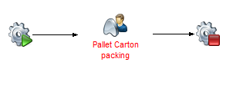

61. Process: INV001 Pallet Carton Packaging

Process Content

* Pallet Carton Packaging

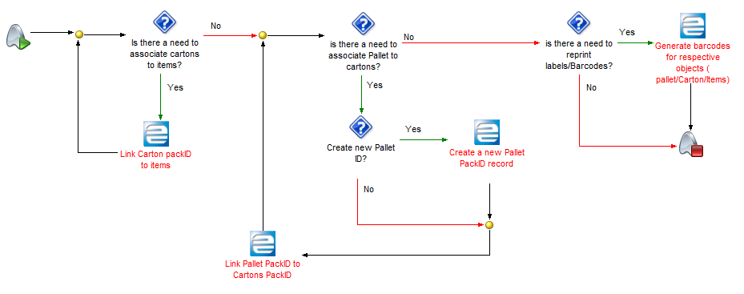

62. Process: INV001 Pallet and Carton Packaging, Stage Pallet carton Packaging

**GAPs/ Configuration changes Identified:**

|  |  |  |  |
| --- | --- | --- | --- |
| Definition | Type |  | Comments |
| PackIDs in Epicor to support Pallet/Carton | Configuration/Enhancement |  | PackageIDs are tobe used to work with Pallets and cartons in storage as well as picking transactions. |
| Item/stockID should be associated with pallet |  |  |  |

INV002 inventory Movements

|  |  |
| --- | --- |
|  | User Notes |
|  | Process definition:  This process handles the steps needed to ensure a proper controlled way of moving stock form one location to another while keeping system updated from a transaction perspective. Handhelds and warehouse queue transactions are to be used. |

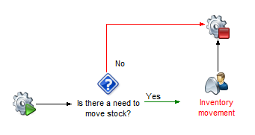

61. Process: INV002 inventory Movements

Process Content

* Inventory Movement

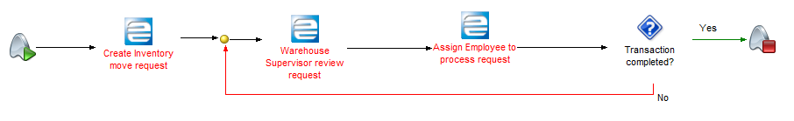

61. Process: INV002 inventory Movements, Stage: Inventory Movement

**GAPs/ Configuration changes Identified:**

|  |  |  |  |
| --- | --- | --- | --- |
| Definition | Type |  | Comments |
| Expiry date dashboard | Dashboard |  | Expiry dates for items to be provided on a dashboard to review close to expiry items and expired items |
| Program and donor field on the lot record | Enhancement |  | In order to track donor and Programs against quantities in stock 2 fields are to be added and logic provided in lot table. |
| Items consumption | Configuration/Dashboard |  | Items are to be allocated as assets towards an employee for tracking purposes. |
| Part Transaction History Tracker | Dashboard/tracker |  | Should have date filters |
| Stock ledger | Report |  | Showing stock movement with opening balance, receipts, issues, and closing balance |

INV003 Inventory Counts

|  |  |
| --- | --- |
|  | User Notes |
|  | Process definition:  Process handles inventory counting at MSD, which can be done with ABC codes or as full inventory count. |

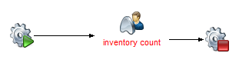

68. Process: INV003 Inventory Counts

Process Content

* Inventory Count

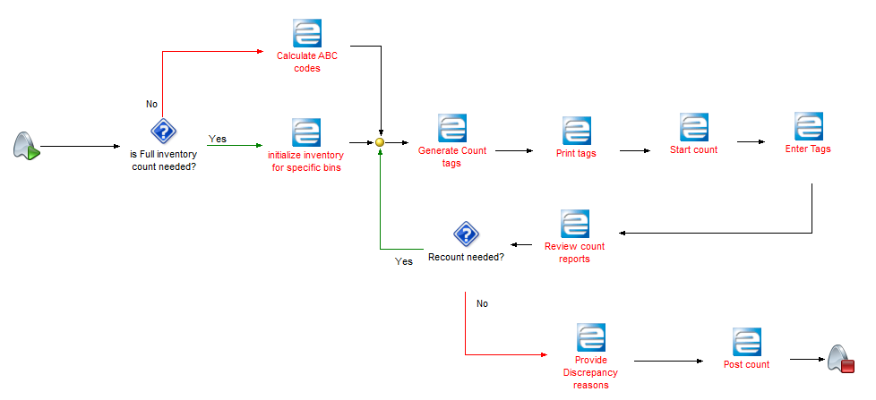

Define count calendar

69. Process: INV003 Inventory Counts, Stage: Inventory Count

**GAPs/ Configuration changes Identified:**

|  |  |  |  |
| --- | --- | --- | --- |
| Definition | Type |  | Comments |
| Bins and inventory count on warehouse and bin level. | Enhancement |  | Ability to filter out bins per warehouse and run inventory count |

INV004 Stock Inspection

|  |  |
| --- | --- |
|  | User Notes |
|  | Process definition:  This Process handles the tracking of items in stock that need to be inspected and generating a corresponding record in Epicor database to mark these items and quantities for inspection status. |

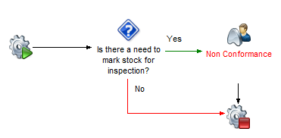

68. Process: INV004 Inventory Counts

Process Content

* Non conformance

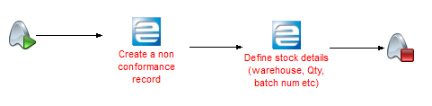

68. Process: INV004 Inventory Counts, Stage: Non conformance

**GAPs/ Configuration changes Identified:**

|  |  |  |  |
| --- | --- | --- | --- |
| Definition | Type |  | Comments |
| Sample fail functionality | Enhancement |  | Ability to fail a partial quantity from the total batch which is marked to be inspected, without the need to transact the full quantity |

Inspection

The following item(s) are in this Group:

* INS001 Inspection Process

|  |  |  |  |
| --- | --- | --- | --- |
|  | |  | | --- | | User Notes | | Process Group definition:  This group contains the processes that are used in the business activities of a company related to inspection needs.  These include the following:         Identifying from where the specific quantities needing inspection came from.  Assigning an inspector user to carry out the inspection  Traceability of results related to the specific lot/batch number and support with reason codes  The handling of a sales originating as a result of an estimate, quote or directly from a customer  Supporting processes as a result of inspection process (DMR) and traceability in the system. Decision making and status update in regards to DMR disposition. | |

INS001 Inspection Process

|  |  |
| --- | --- |
|  | User Notes |
|  | Process definition:  This process handles the items flagged as needing inspection, inspecting them, submitting a sample, as well as generating a result of quantities currently under inspection process. This will follow up activities and decision making what to do depending on the result of the inspection activity. |

71. Process: INS001 Inspection Process

Process Content

* Inspection Process

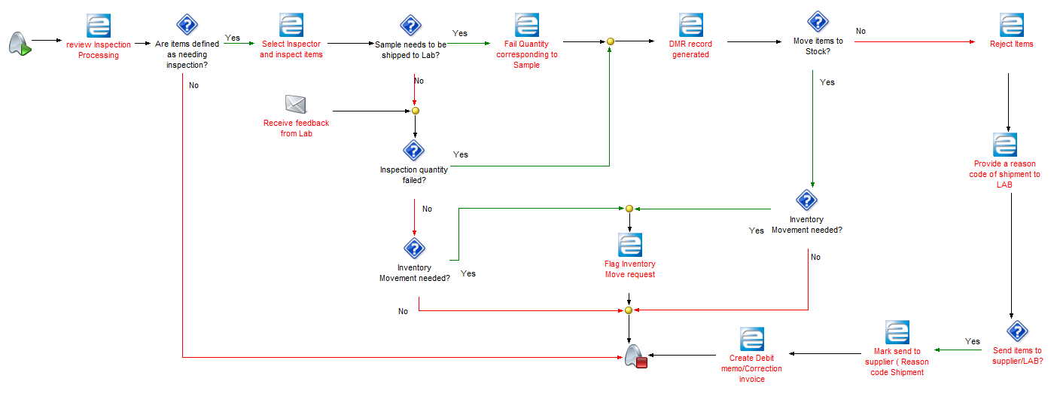

72. Process: INS001 Inspection Process, Stage: Inspection Process

**GAPs/ Configuration changes Identified:**

|  |  |  |  |
| --- | --- | --- | --- |
| Definition | Type |  | Comments |
| Ability to flag a partial quantity from a lot as fail without passing/failing the full lot | Enhancement |  | Quantities from lots are sent as a sample to labs. System needs to be able to leave remaining quantity in inspection status. |
| Status checkbox needed in DMR (accept/reject) | Custom Fields |  | A status checkbox to provide status update in DMR and should provide text box for reason of rejection once rejected as mandatory field |
| Inspection workbench | Dashboard |  | Informing QA for items which need to be inspected |

Sales Management

The following item(s) are in this Group:

* SAM001 Case Creation
* SAM002 Sales Orders
* SAM003 RMA

|  |  |
| --- | --- |
|  | User Notes |
|  | Process definition:  This process outlines setting up of cases to support Sales processes, defining Sales orders and capturing process related to returns of products being sold from customers:  Case Creation allows to define date ranges when orders can be placed, when they can be shipped and when they can be invoiced against a predefined list of customers, and grouping multiple orders against these records to be used in fulfilment.  Handling of customer demand in the form of sales orders in order to be able to supply stock efficiently.  The handling of the return of goods from a customer with or without the previous issue of an RMA (return from a customer). |
|  |  |

SAM001 Case Creation

|  |  |
| --- | --- |
|  | User Notes |
|  | Process definition:  This process enables the creation of Case records with relevant parameters against sales order records to be later used in fulfilment. |

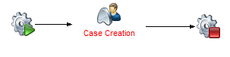

75. Process: SAM001 Case Creation

Process Content

* Case Creation

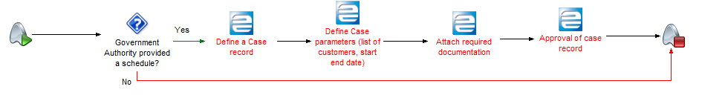

76. Process: SAM001 Case Creation, Stage: Case Creation

**GAPs/ Configuration changes Identified:**

|  |  |  |  |
| --- | --- | --- | --- |
| Definition | Type |  | Comments |
| Case record creation | Enhancement |  | A case needs to be able to be created with relevant details in the system and easily attached to multiple sales order records. |

SAM002 Sales Orders

|  |  |
| --- | --- |
|  | User Notes |
|  | Process definition:  This process handles the activities of creating demand via sales orders coming from customers which MSD actions and supplies the relevant quantities. The sales orders can be created manually, as well as come via an interface (ELMIS) from the customers. It is expected that a high volume of orders are transacted on a daily basis. MSD also needs to define items coming from original demand, which cannot be supplied from stock (0 quantities on order). Counter sales functionality will be used for certain locations where there are walk in customers. It is expected that Quotes will be utilized for certain customers where pro-forma invoice is required. It has been identified that sales can be of the following types: Credit, normal, on account and vertical. |

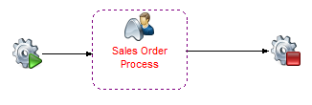

76. Process: SAM002 Sales Order Process

Process Content

* Sales Order Process

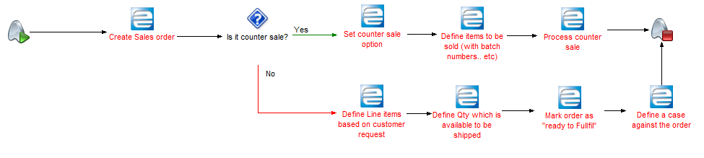

76. Process: SAM002 Sales Order Process, Stage: Sales Order Process

**GAPs/ Configuration changes Identified:**

|  |  |  |  |
| --- | --- | --- | --- |
| Definition | Type |  | Comments |
| Reason code on sales order | Custom fields |  | A reason code is needed in case the line item cannot be supplied |
| Case to be linked to an order(s) | Enhancement |  | Case record needs to be able to be defined against multiple order records. |
| Original quantity field | Custom fields |  | A custom field needs to be provided to capture original quantity. |
| Ready to fulfill flag to be mandatory | BPM |  | Ready to fulfill flag on sales order to be mandatory |
| Substitute and alternative item to show available quantity | Custom Fields |  | Substitute and alternative item to show available quantity on sale order line level. |
| Order to have a type field | Custom fields |  | The order is able to be differentiated based on order type (Normal, vertical, ILS, Special, Free Issue etc). |
| Customer balance to be shown | Custom field |  | Customer balance to be reduced as item lines are entered. |
| Permit requirement for particular items being sold | Enhancement |  | Items that have special conditions require permits before they can be sold. |

SAM003 RMA

|  |  |
| --- | --- |
|  | User Notes |
|  | Process definition:  This process handles the receipts from Customers based on issues with the delivered products, and managing the return back to MSD. Also this allows to link up relevant records to the RMA record in order to provide tracking possibilities throughout the system. The RMA process is linked to inspection in order to trigger investigation upon arrival of products. |

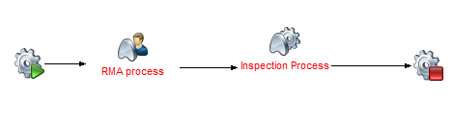

76. Process: SAM003 RMA Process

Process Content

* RMA Process

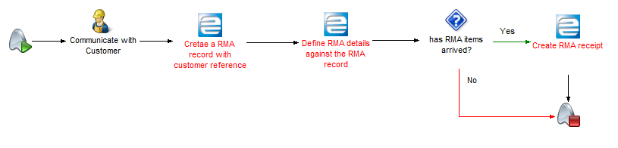

76. Process: SAM003 RMA Process, Stage: RMA Process

**GAPs/ Configuration changes Identified:**

|  |  |  |  |
| --- | --- | --- | --- |
| Definition | Type |  | Comments |
| RMA process needs to linkup to DMR processing | Enhancement |  | When items failed in inspection coming from RMA, should be pushed to DMR processing |
| Restriction on receiving greater qty than what was sold | BPM |  | Order shipment linkup to prevent greater quantity from being received to what was shipped. |

Shipping

The following item(s) are in this Group:

* SHP001 Case/order fulfillment
* SHP002 Truck Allocation
* SHP003 Creating Customer Shipments

|  |  |
| --- | --- |
|  | User Notes |
|  | Process Group definition:  This group contains the process used to identify stock available at MSD and use tools such as fulfillment workbench, allocation of trucks and shipments to transact in an efficient manner. |

SHP001 Case Order fulfillment

|  |  |
| --- | --- |
|  | User Notes |
|  | Process definition:  This process handles the stock allocations against confirmed sales orders. Fulfillment is done based on demand coming from sales order or transfer orders. The system needs to be able to utilize a FeFO (First expiry, first out) logic with lot tracked items. Picking transactions are then pushed once the allocations are done. |

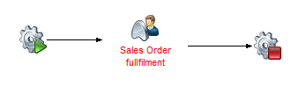

80. Process: SHP001 order Fulfillment

Process Content

* Order Fulfillment

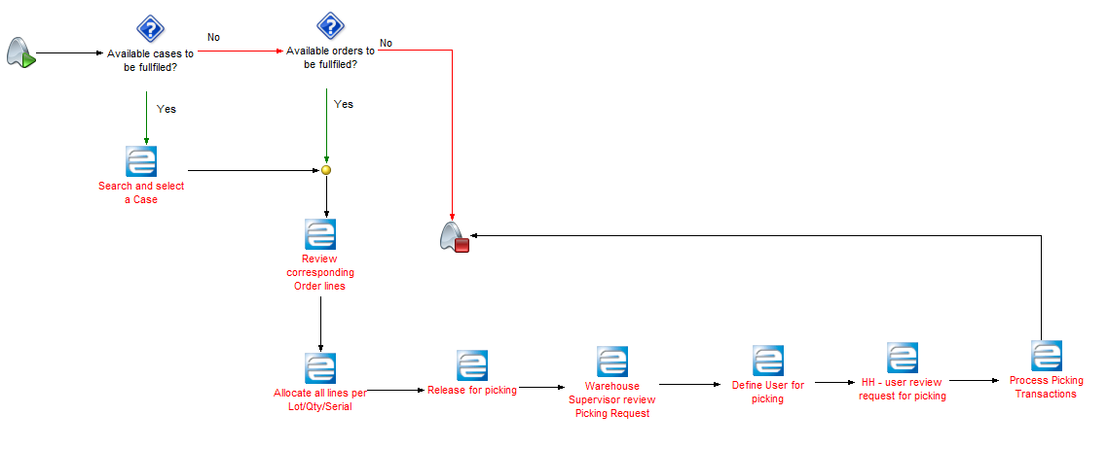

80. Process: SHP001 order Fulfillment, Stage: Order Fulfillment

**GAPs/ Configuration changes Identified:**

|  |  |  |  |
| --- | --- | --- | --- |
| Definition | Type |  | Comments |
| Fulfillment workbench enhancement | Enhancement |  | Ability to integrate Case into fulfilment workbench and provide reservation/allocation options. Performance requirement ( over 1000 lines processed at the same time), PackIDs are to be supported. |
| Picking transactions to be grouped per location | configuration |  | Ability to group picking transactions for lot numbers per locations to allow users to reduce number of movements. |
| Case records creation | Enhancement |  | Case records are to be generated and stored to group orders together |

SHP002 Truck Allocation

|  |  |
| --- | --- |
|  | User Notes |
|  | Process definition:  This process relates to creating and using Truck in Epicor 10, where the system is expected to store truck related information in the database and allocate trucks to different shipments as required by MSD. Truck measurements and calculations against shipments are supported. |
|  | 80. Process: SHP002 Truck Allocation  Process Content   * Truck Definition and allocation     80. Process: SHP002 Truck allocation, Stage: Truck Allocation |

**GAPs/ Configuration changes Identified:**

|  |  |  |  |
| --- | --- | --- | --- |
| Definition | Type |  | Comments |
| Truck record | Enhancement |  | A truck identification needs to be stored in the system together with possibility to link it to multiple shipments and transfer shipments. |

SHP003 Customer Shipments

|  |  |
| --- | --- |
|  | User Notes |
|  | Process definition:  This process handles the activities of transforming allocated stock to shipments against sales orders and linkup to Truck records where needed, in order to support shipments towards customers. |

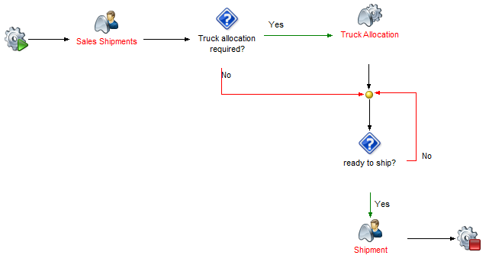

80. Process: SHP003 Customer Shipments

|  |  |  |  |  |  |  |  |  |  |  |  |  |  |  |  |  |  |
| --- | --- | --- | --- | --- | --- | --- | --- | --- | --- | --- | --- | --- | --- | --- | --- | --- | --- |
|  | Process Content   * Truck Definition and allocation     80. Process: SHP003 Customer Shipments, Stage: Sales Shipments   * Shipment     80. Process: SHP003 Customer Shipments, Stage: Shipment  **GAPs/ Configuration changes Identified:**   |  |  |  |  | | --- | --- | --- | --- | | Definition | Type |  | Comments | | Permit is required to be able to ship out specific items | Enhancement |  | A permit needs to be verified agaist a specific items before they can be shipped. | | Inspection to be forced before shipping | Enhancement |  | Shipments need to be inspected (mandatory) | | Expired items to be stopped from shipping | BPM |  | Expiry dates to be tracked at picking/shipping | |
|  |  |

SHP004 Transfer Orders

|  |  |
| --- | --- |
|  | User Notes |
|  | Process definition:  This process handles the activities related to movements of MSD inventory from one location to the next, with the use of transfer orders, receipts and truck records. |

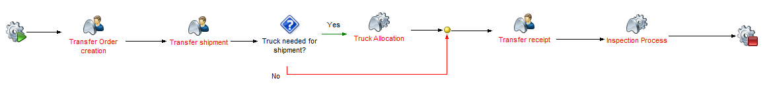

80. Process: SHP004 Transfer Orders

Process Content

* Transfer Order Creation

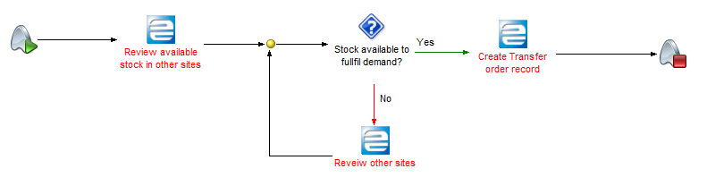

80. Process: SHP004 Transfer Orders, Stage: Transfer Order Creation

* Transfer Order Shipment

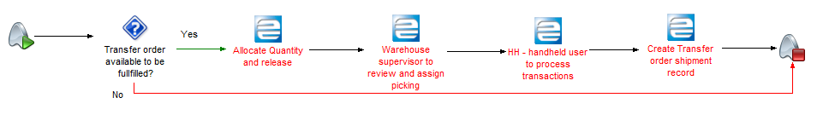

80. Process: SHP004 Transfer Orders, Stage: Transfer Order Shipment

* Transfer Order Receipt

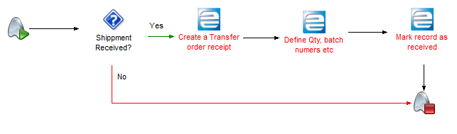

80. Process: SHP004 Transfer Orders, Stage: Transfer Order Receipt

**GAPs/ Configuration changes Identified:**

|  |  |  |  |
| --- | --- | --- | --- |
| Definition | Type |  | Comments |
| Receipt of partial line qty | N/A |  | Ability to receive partial quantity of a line |

Integrations

The following integrations were discussed at MSD during onsite meeting which need to be considered during implementation. This document will not provide specific solutions and architecture for the integration requirement. It will be used to list the high level areas that need to be reviewed and considered:

* ELMIS(Electronic logistics management information system)
* Business intelligence and analytics system
* E-Procurement system

|  |  |
| --- | --- |
|  | User Notes: |
|  | ELMIS:  The ELMIS system is used to generate demand coming from customers, where sales orders are being utilized via a web based User interface. This allows customers to place orders to MSD once they manage to get the order approved. After this the order is confirmed as demand that MSD will supply. Current data format is csv file. It is expected that more than 100 sales orders are generated this way per day from customers towards MSD.  Business Intelligent and analytics system:  Business Intelligence and analytics system is used to gather procurement based information from Epicor 9 database, which is later utilized by a separate software. It is expected that the same data and format is to be identified in Epicor 10 database and extracted. Current method used is service connect workflow.  E- Procurement system:  Not currently operational, therefore will not be included in further detail in this document. |

**GENERAL COMMENTS**

1. E10 implementation should be web-based and with mobile access
2. Customer receipt acknowledgement functionality to be implemented using HH/tablet/ mobile phone ( like what DHL does)
3. Consider use of HH barcode functionalities in all processes
4. Labelling of bins using barcode labels for scanning to confirm bin during picking or stock counting
5. Remaining Shelf life calculation of lot number should be displayed in receiving screen
6. Ability to revoke access privilege after a predefined period of time
7. Audit trail as opposed to change log
8. Should prevent deletion of transactions ( should allow soft deletion by flagging deleted transactions)
9. Pricelist table and userfile table should capture creation date, modified date, created by, modified by
10. Part created should default to all warehouses and plants( sites)
11. Counter sales selling unit conversion
12. Process of receipt and issues of consumables, services and Assets
13. Part number should have purchasing and selling unit of measure
14. During part creation, should be able to flag as checkbox for Inspection required by default